AGENT RECRUITING
By Dan Wood

My top links and tools for recruiting:

upwork.com
I use upwork for outsourcing. Things like creating my cold calling lists, cleaning my database and general help with anything I don’t want to be doing myself.

join.me
I use join.me as free way to instantly share my computer screen. Think of helping agents with offers, onboarding a new agent and basically saving the time to meet in person (when a phone call and virtual meeting will get the job done quicker).

bit.ly/GOBombBomb
BombBomb is a must have when recruiting. It’s the quickest and easiest way to make and send videos. Think of recruiting videos, building report and establishing relationships over time.

bit.ly/GoBoomerang
Boomerang for Gmail is one of the 3 things I can’t do business without. It basically makes my email more manageable. I can put things off and it reminds me, I can send later and set up reoccurring messages.

bit.ly/GoTrelloFree
Trello is basically my project board. It’s free and it saves my checklists, I can assign people to tasks, I can save files, videos & images to specific projects I have going on.

bit.ly/GoLastpass
Creates and saves all my passwords. It’s team based, so you can assign team members specific access VS just giving it out to everyone.

bit.ly/GoJing
Jing allows you to record your computer screen. This is perfect for staff instructions, long emails, feedback, etc.

brokeragenation.com/managers – Group coaching, landing pages, websites and other agent recruiting tools. Call or text Dan at 905-903-5442 or coaching@danwood.ca

Notes & things to look deeper at:

______________________________  ______________________________  ______________________________  ______________________________  ______________________________  ______________________________  ______________________________  ______________________________  ______________________________  ______________________________  ______________________________  ______________________________  ______________________________  ______________________________  ______________________________  ______________________________  ______________________________  ______________________________  ______________________________  ______________________________  ______________________________  ______________________________  ______________________________  ______________________________  ______________________________  ______________________________  ______________________________  ______________________________  ______________________________  ______________________________  ______________________________  ______________________________  ______________________________  ______________________________  ______________________________  ______________________________  ______________________________  ______________________________  ______________________________  ______________________________  ______________________________  ______________________________  ______________________________  ______________________________  ______________________________  ______________________________  ______________________________  ______________________________ | ______________________________  ______________________________  ______________________________  ______________________________  ______________________________  ______________________________  ______________________________  ______________________________  ______________________________  ______________________________  ______________________________  ______________________________  ______________________________  ______________________________  ______________________________  ______________________________  ______________________________  ______________________________  ______________________________  ______________________________  ______________________________  ______________________________  ______________________________  ______________________________  ______________________________  ______________________________  ______________________________  ______________________________  ______________________________  ______________________________  ______________________________  ______________________________  ______________________________  ______________________________  ______________________________  ______________________________  ______________________________  ______________________________  ______________________________  ______________________________  ______________________________  ______________________________  ______________________________  ______________________________  ______________________________  ______________________________  ______________________________  ______________________________ | ______________________________  ______________________________  ______________________________  ______________________________  ______________________________  ______________________________  ______________________________  ______________________________  ______________________________  ______________________________  ______________________________  ______________________________  ______________________________  ______________________________  ______________________________  ______________________________  ______________________________  ______________________________  ______________________________  ______________________________  ______________________________  ______________________________  ______________________________  ______________________________  ______________________________  ______________________________  ______________________________  ______________________________  ______________________________  ______________________________  ______________________________  ______________________________  ______________________________  ______________________________  ______________________________  ______________________________  ______________________________  ______________________________  ______________________________  ______________________________  ______________________________  ______________________________  Need Help? Call or Text Dan:  905-903-5442

My resources and contact info:

Want to watch more videos specific to recruiting and the real estate business? Save these links to watch later:

- Recruiting ideas: www.brokeragenation.com/managers
- Recruiting Webinar: bit.ly/RecruitingWebinars
- More YouTube videos: www.youtube.com/user/DannyWoodVideos

Need help with recruiting? I have 3 recruiting programs…

- I run targeted recruiting ads for you, based on your email list.
- I give you a white label training program and landing pages that re-brands as you. It’s used as a recruiting tool and relationship builder.
- We also have a “thank you” video program, 4 year drip and recruiting websites.
- Interested? Let’s talk confidentially.

I’d love to do a demo with you and share my screen. Please contact me below, or book a time here: www.bookdan.me

Dan Wood
coaching@danwood.ca
905-903-5442
http://www.BrokerageNation.com

PS: Ask me about my live office seminars. We can hold it like a big event for your agents…
+ you can use the event as a recruiting touch and reason to be reaching outside agents.

We have ½ day and full day options. $1,800 - $3,000

Topics covering:

- Landing pages and seller leads.
- Facebook advertising for buyers, sellers, open houses and listings.
- Lead follow-up and working a database.
- Video (creating, sharing and real estate examples).
- Google pay-per-click.
- Outsourcing and virtual assistants.
- My top tools and apps for REALTORs.
- Prospecting and door knocking.
- Checklists: Just listed, just sold, open house, new buyer, buyer close.
- Referrals and a 90 day plan.
- YouTube & more!

Attention: Real estate managers & broker owners… below you’ll find a sample business plan. It’s totally free and you can do it over the next 90 days. What you’ll get:

- Agent recruiting scripts & ideas.
- A 90 day business plan (for growing your brokerage).
- No cost ongoing! All you need is a phone and a list of agents to be calling.
- It’s self paced. Do it on your own. Anytime - now or in the New Year.
Before you get started it’s important to download this “Time Blocking” tool:

Download here: bit.ly/DL-timeblockingsheet
Watch here: youtu.be/eiCN_yMmkMI

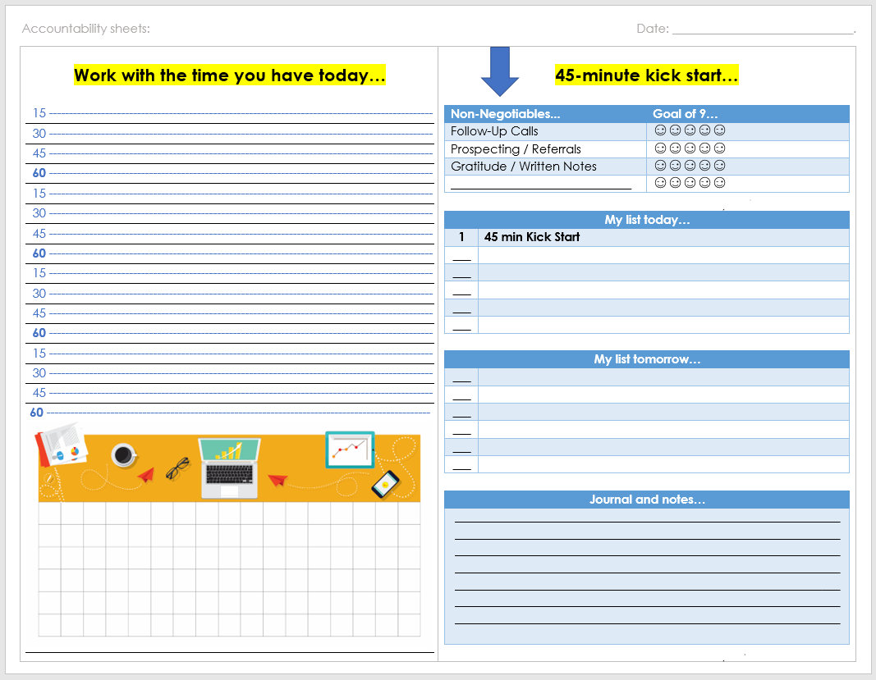

Once you can master and focus your time, you can master and focus on anything!
Ready to start recruiting?

Attracting talent is a relationship business.

Sometimes we need to do what we preach. You tell your agents to work for referrals and to follow-up with leads. Right?

You tell them to time block. To prospect… but shouldn’t you be doing the same?

This exercise is going to help you:

- Establish a target list of agents to be calling.
- Create a database or spreadsheet for future use.
- Manage your time going forward.
- Choose the scripts / texting messages that work for you.

To start you’ll need a target list of at least 100 agents to call.

If you don’t have a list. You can start by picking your top 3 competing brokerages (in a 30 minute radius of your office). Stay local because agents tend to work at the best brokerages that are closest to them. Where they live and work where they play.

So who are the top 3 offices near your brokerage?

1. ________________________________________
2. ________________________________________
3. ________________________________________

Now try listing the 20 other brokerages in your direct area. A good exercise is to start with is the franchises...

REMAX A
REMAX B
REMAX C
REMAX D
REMAX E
etc

Keller Williams A
Keller Williams B
Keller Williams C
Keller Williams D
Keller Williams E
etc

Try and do that for each of the brands in your area:
Century 21
Coldwell Banker
ERA
EXIT
etc

Who are the independents?

________________________
________________________
________________________
________________________
________________________

Any cloud based brokerages?

________________________
________________________
________________________
________________________
________________________

*THE MORE THE BETTER, BUT TRY TO FOCUS ON THE OFFICES WITHIN 30 MIN OF YOUR LOCATION(s)
To start building your list. Go to the local office websites above.

They all should have a agent roster page or search agents page. This will give you the name and cell numbers of local agents who already work in your area.

The local association website should also post the brokerage roster for each office if you can’t find a agent roster on the brokers website.

Services that offer agent lists would be REstats in Canada or BrokerMetrics in the USA… but both are expensive and offer WAY more than just providing lists. They also show sales & stats so you can target agents based on production.

However you get the list, you’ll want them in a CSV file showing: First Name, Last Name, Brokerage, Cell Email, Contact Date, Notes. Like this:

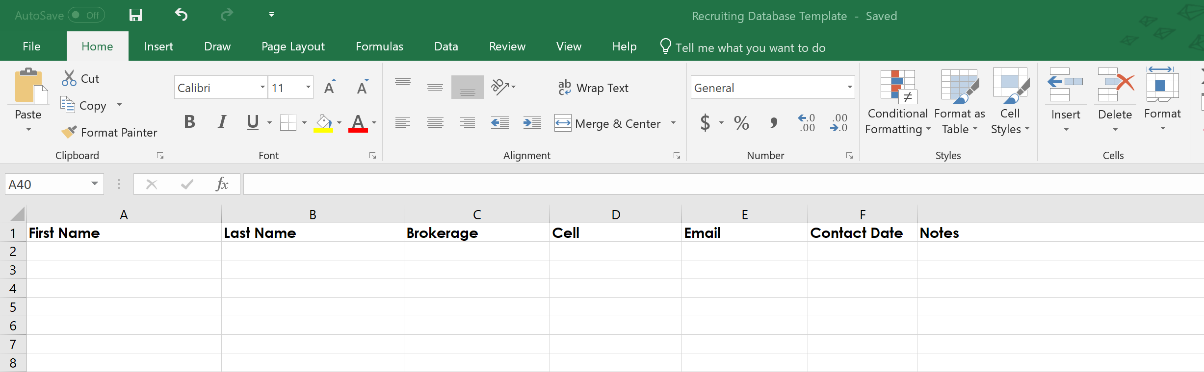

You can outsource tasks like this to someone on http://www.upwork.com

- This is a video showing how I outsource and hire people: https://www.youtube.com/watch?v=bXCDyKctmvQ

If you don’t have a database start a simple excel sheet if nothing else. (Google docs is a free version if you don’t have excel). I also suggest http://bit.ly/AgileCRMfree because it’s FREE! It’s also super powerful and modern.

If you have a real estate database (CRM) by all means you should be putting them directly into that and creating a list so you can print it off, call them, direct mail & email (if you have permission).

I suggest bit.ly/GOBombBomb (not as a CRM but as a relationship building tool). It allows you to upload all your contacts, send them each personal videos, you can mass email, create drip plans & more! Lots of databases have those features, but the video feature is what truly stands out.

Think of it as visual voicemail. Imagine this…

You call the agent and get his/her voicemail. You leave a 30 second voicemail. They see the annoying message notification flashing. They need to check the mail, enter a password and scramble to find a paper & pen.

Avoiding that you use video instead. You hang up and send them a video message directly from your phone using the app. In it they will see your video, your email signature (including the phone number to easily reply).

This makes it easier for them to actually call you back. It also gives them the easier chance to hit the reply button, text or email. It gives them choice at the click of a button!

This builds the mindshare if nothing else. Creating that know you, like you, trust you factor.

- Try BombBomb for free: http://bit.ly/GOBombBomb
- If they ask for a promo code it’s: BROKERAGENATION
You don’t need to use video for this 90 day challenge. I just suggested it because many will find it a benefit and it actually makes your job easier.

Ready to get started? This is your new plan for the next 12 weeks!

- Print your database and staple the sheets together. (This is usually called exporting and you’ll get a excel sheet – please print that, just remove the columns you don’t need).
- Now take the total number of agents in your database and divide that number by 12.
For example… my database has ________ people in it. (divide that number by 12 = ________).

This will be the number of calls you will be doing per week for the next 12 weeks.

If I had a list of 300 people. I’d divided 300 by 12. That gives me 25 people a week to call. So every week I’d focus on contacting 25 people.

Take whatever number you wrote above and break the list into 12 equal groups.

Grab the list you stapled together and count by whatever your number is. Draw a line. Count by that number again and draw another line. Keep doing this and you’ll have 12 equal groups of contacts broken down.

I show agents the basic idea in this video: youtu.be/ujZ5hSRPDS0

See how this breaks your database into smaller manageable sizes so you can be consistent with it over time?
Every week for the next 12 weeks you’ll call whatever your number is.

• Week one is group one.
• Week two is group two… and so on.

This is a 3 day a week plan. Do one day, three days or five days a week. Just do whatever makes sense for you.

In a 3 day week. I’d block off 1-2 hours every Monday, Wednesday & Friday.

- On Monday call group one. Use a script (in next section) if they answer. If they don’t answer - don’t leave a voice mail.
- Try calling again on Wednesday. If they still don’t answer, don’t leave a voice mail…
- Try calling again on Friday and this time leave a voice mail for those not reached (you could also send a BombBomb video bit.ly/GOBombBomb :-)
- Update your database and notes because next week you’ll move on to the next group.
- On week two do group two. On week three, do group three. Just focus on one group at a time.
- That’s the basic idea. Do this every week for the next 12 weeks.
- By the end you’ll see that the people who were in group one will be now be 90 days old since you last talked. This is a perfect time to start over again.

With this simple system you can call 3-4 times a year. If nothing else you should be calling them at least once a year. Something is better than nothing.

Think about it…

How many times did you talk to a recruit who says they are good where they are and 3 months later you see they joined another brokerage? What happened? Time.

Time passed and circumstances changed. That’s why you need to build these relations over time. That’s why you need to keep calling. It’s a timing thing and if you don’t call you’ll never get the right time, but if you call 2-4 times a year you’ll greatly improve the timing.

As a added bonus you’ll be building and cleaning your database over time. This is the real win. Getting agents is the goal, but it takes a lot of no’s to get the few yes’s. So shift your thinking.

Say this week you called 25 people and nothing really happened. Just a bunch of voice mails, no call backs and possibly a disappointing conversation with a angry agent.

You didn’t get anything right? Wrong. You now have 25 contacts updated in your database!

When I’m calling someone I take note on missing info before I call. If someone is missing a email I’ll try and get that during out conversation. If they are missing a mailing address. I’ll get it. I’ll make notes on our conversation. Things they are up to in life. Things we talked about. That way when I call them again in 3 months, 6 months or a year. I’ll have a updated database that makes my job easier. Easier to pick up the phone and carry on a conversation. To truly build relationships.

What do I say when calling? Agent recruiting scripts…

How do you call agents without feeling like a pest?

For the next 90 days you pick a script / a story / or a reason to actually be calling (and stick with it).

Think of it as a seasonal promotion, a reason to be reaching out, or a way to reconnect.

Recruiting ideas you can make a script for:

• Targeting buyer agents on teams (they might be ready to go on their own).
• Offering access to online training videos.
• Inviting them to live training sessions or webinars.
• Grand openings / re-openings.
• Summer BBQ / office open house.
• To meet simply for coffee.
• A hard sell “join our office” confidential meeting.
• Focus on the numbers (if you worked at our office last year you would have saved $XXXX).
• New agents who started a year ago (probably didn’t see the growth they wanted and might feel your office is more supporting).
• Offering them a goal setting exercise.
• Offering them free time blocking tools.
You basically want to pick a topic and brainwash yourself. If anyone asks “what’s new” or “how are you doing”… it should trigger a reply about your current promotion…

Question: Hey Dan what’s new?

Answer: Oh our office is really excited about (_____________________)… do you know any agents who might be interested?

See how many conversations you have daily that could easily lead you to your next agent? Everyone knows a REALTOR. Leverage those conversations with purpose and you’ll grow organically without much effort.

You just need to stick with one promotion at a time. Every 90 days. Pick one and stick with it.

I pick one topic / promotion at a time. So this quarter might be about the online training access. The quarter after that will be about buyer agents. The quarter after that could be a office open house with training sessions and food.

I don’t mix them up. I pick one and that’s my mission. I’ll promote it on social media, email blast my list and start cold calling. Rinse and repeat. Every quarter. Every 90 days.

It keeps things fresh. A renewed energy. A new reason.

Come up with your own scripts and mini promotions. Whatever makes you excited!

Below are a few samples to get you thinking. Pick the one you like and modify to fit your needs & language.

SCRIPT: Targeting buyer agents on teams (they might be ready to go on their own).

Hi (__________ agents name) it's (___________ your name) from (_______________ brokerage). Did I catch you at a good time?

- let them answer.

I’m looking for more agents like you. If you ever decided to go out on your own (or start a team of your own team). I’d love to talk about it confidentially. I’m just talking in the future. You never know.

Have you ever thought about it?

- let them answer.

Have a real conversation. No script needed. Be real. Be you. End by asking permission to keep in touch and update missing info.

* Caution calling to recruit agents is one thing, but calling buyer agents of teams is totally different. It could ruffle the feathers of not just the team leader but also the management of the company. Be politically correct. It’s your business to and you have a right to do your job. This approach is just more direct then others and if done wrong could really backfire. I also know regardless of all that. Buyer agents leave teams every year because working a 50/50 split and selling 20 homes VS selling 10 homes and keeping 100% equals the same pay for ½ the effort and by this time they are established, have a database and know the ropes.

I put it in the same category as the agents who call expired listings. It’s more aggressive but it makes sense to fish where the fish are.

SCRIPT: Offering access to online training videos.

Hi (__________ agents name) it's (___________ your name) from (_______________ brokerage). Did I catch you at a good time?

- let them answer.

We have a online training program and I’m reaching out to select REALTORs in the area. I thought you might like it.

It covers (__________________) would you be interested?

- let them answer.

If you could improve one area of your business… what would it be?

- let them answer.

Have a real conversation. No script needed. Be real. Be you. End by asking permission to keep in touch and update missing info.

* Use this as a ice breaker and a way to start going deeper with people. You should become a resource center. Follow up and surprise them with a package, email or facebook message linking them to a article or something that helps in the direction they are going.

If you don’t have a online training program you might want to look at our white label training videos / recruiting programs: www.brokeragenation.com/managers

SCRIPT: Inviting them to live training sessions or webinars.

Hi (__________ agents name) it's (___________ your name) from (_______________ brokerage). Did I catch you at a good time?

- let them answer.

We have a live training session on (__________ date) and it’s covering (____________________).

I’m reaching out to select REALTORs in the area. I thought you might like it.

If you can’t make the date I can keep you posted on future ones.

- let them answer.

Have a real conversation. No script needed. Be real. Be you. End by asking permission to keep in touch and update missing info.

* Use this as a ice breaker and a way to start going deeper with people. You should become a resource center. Follow up and surprise them with a package, email or facebook message linking them to a article or something that helps in the direction they are going.

SCRIPT: Grand openings / re-openings.

Hi (__________ agents name) it's (___________ your name) from (_______________ brokerage). Did I catch you at a good time?

- let them answer.

We are having a grand opening on (__________ date) and I wanted to invite you. We’ll be having food and showing off the new digs.

I personally wanted to invite you… and to say you can actually stop by anytime. Our doors are always open to you. Think you can make it?

- let them answer.

Thanks for thinking about it! Our office is here for you if you ever look at your options. I’ll keep in touch.

* Don’t go for the hard sell to “join our office” (unless you feel you should be). I’d approach this is a simple touch and feeling around for the right opportunity. You should be calling them in the future anyways. So don’t clear cut the database. Just gradually work it over time. Let the fruit fall when ready.

PS: If you are opening a newly renovated space I suggest hiring a virtual photography / video company to come in and capture the freshly painted perfect office. It’s something you could upload on YouTube and include in your email signature. Allow them to see the space without coming in. Show them the grass is greener on the other side

During your grand opening we could do a seminar for the agents.

A 45 min training session could be a great way to kick things off. We can do it live or virtually. In Canada or the states. Contact Dan Wood at 905-903-5442 | www.danwood.ca/contact

SCRIPT: Summer BBQ / office open house.

Hi (__________ agents name) it's (___________ your name) from (_______________ brokerage). Did I catch you at a good time?

- let them answer.

We are having a (summer BBQ / office open house) for agents and I wanted to invite you. It’s (__________ date).

If you can’t make it just know our doors are always open to you. Think you can make it?

- let them answer.

Thanks for thinking about it! Our office is here for you if you ever look at your options. I’ll keep in touch.

* Don’t go for the hard sell to “join our office” (unless you feel you should be). I’d approach this is a simple touch and feeling around for the right opportunity. You should be calling them in the future anyways. So don’t clear cut the database. Just gradually work it over time. Let the fruit fall when ready.
During any events like this you can always include a training session. If you need help we could provide a session for you.

We can do it live or virtually. In Canada or the states. Contact Dan Wood at 905-903-5442 | www.danwood.ca/contact

SCRIPT: To meet simply for coffee.

Hi (__________ agents name) it's (___________ your name) from (_______________ brokerage). Did I catch you at a good time?

- let them answer.

If you know them:
I wanted to reconnect and catch up. Think we could meet up for coffee this week?

If you don’t know them yet:
I know of you, but we don’t know each other. Think we could meet up for a coffee this week? I’m always looking to grow my sphere of local agents and find it important to grow my personal network.

- let them answer.

If no:
That’s ok. Do you mind if I keep in touch? We always have ongoing agent training and I’d love to offer you that. Update your database and move on.

If yes:
End with a real conversation. No script needed.

Send them a email confirming the date, time & location. Include all your contact info and have your admin call them the day before to remind them.

SCRIPT: A hard sell “join our office” confidential meeting.

Hi (__________ agents name) it's (___________ your name) from (_______________ brokerage). Did I catch you at a good time?

- let them answer.

I’m calling because our office has some options I wanted to go over with you. I know you’re probably happy at (_____________ brokerage) but we might have options that fit your future. Think we could meet just to see the possibility? Like a yearly business plan?

- let them answer.

If no:
That’s ok. Do you mind if I keep in touch? We always have ongoing agent training and I’d love to offer you that. Update your database and move on.

If yes:
End with a real conversation. Set the appointment. No script needed.

SCRIPT: Focus on the numbers (if you worked at our office last year you would have saved $XXXX).

Hi (__________ agents name) it's (___________ your name) from (_______________ brokerage). Did I catch you at a good time?

- let them answer.

I’m calling REALTORs who sell 5-10 homes a year because on average our office would save you $X,XXX. I’d love to go over the numbers and share how you can earn more money with the same effort you did last year.

I’m always watching the market and I know what agents produce. I see you as a perfect fit for growth. Think we could meet to go over the possibility? If not for this year maybe next year. You never know.

- let them answer.

If no:
That’s ok. Do you mind if I keep in touch? We always have ongoing agent training and I’d love to offer you that. Update your database and move on.

If yes:
End with a real conversation. Set the appointment. No script needed.

In both cases you should update your database with notes and missing info.

* Brokers can pull lists of agents by units sold, areas they work & companies they work at by using services like BrokerMetrics by terradatum.com in the US or IMSstats.com in Canada. These are great tools for creating a recruiting target list. You could make a list by number of units sold. A list of teams. A list by brand. A list of agents by property type (condo agents, freehold, commercial, etc).

SCRIPT: New agents who started a year ago (probably didn’t see the growth they wanted and might feel your office is more supporting).

Hi (__________ agents name) it's (___________ your name) from (_______________ brokerage). Did I catch you at a good time?

- let them answer.

I’m calling REALTORs who are newer to the industry. You started a year or so ago right?

- let them answer.

I know what it’s like to be self-employed and starting out. Because of that I wanted to reach out and invite you to our brokerage. I know many agents start with a brokerage and switch befor setteling down. It could also give you a fresh rebranding and help build your database.

Think we could meet just to go over future possibilities and what our office has to offer? Training and support is just the start. I’d love to go in more details. Confidentially of course.

- let them answer.

If no:
That’s ok. Do you mind if I keep in touch? We always have ongoing agent training and I’d love to offer you that.

If yes:
End with a real conversation. Set the appointment. No script needed.

In both cases you should update your database with notes and missing info.

* You might be able to make a list of new agents by using BrokerMetrics (terradatum.com) in the US or IMSstats.com in Canada… but I’m not sure. I know the info they can access is determined by each board so it’s different in each city. I also know many boards publish a monthly newsletter and in it they include new members. Listing the names and brokerages of membership changes. Keep these in a file and say it’s January. You’ll grab the November/December issue of last year (11-12 months ago). Look at the new members and call them up. I bet most of them are missing systems, support and accountability.

SCRIPT: Offering them a goal setting exercise.

Hi (__________ agents name) it's (___________ your name) from (_______________ brokerage). Did I catch you at a good time?

- let them answer.

I have a goal setting exercise for REALTORs and thought you might like it? It’s open to all agents and they are using create a fresh business plan going forward. Would you be interested?

- let them answer.

Ok perfect. I’ll send it to you.

If you could improve one area of your business… what would it be?

- let them answer.

Have a real conversation. No script needed. Be real. Be you. End by asking permission to keep in touch and update missing info.

* You could use this video as a “goal setting” resource that you could give away: https://youtu.be/DyGgC64A7cs (or ask me for a updated one coaching@danwood.ca)

Create your own… or get permission from someone else who has a goal setting seminar. It makes for a great conversation starter because you can discover what gets them excited. Helping people find a passion and giving them the tools to move forward.

It also gives you a great reason to follow up. A week or so later you can call them to see what they discovered. Can your brokerage or management help them reach their goals? This is the easiest way to find out.

We have the goal setting session + other online training videos you could leverage. Call us to see what ones will work for you. These are some recruiting recourses to take a look at: www.brokeragenation.com/managers

SCRIPT: Offering them free time blocking tools.

Hi (__________ agents name) it's (___________ your name) from (_______________ brokerage). Did I catch you at a good time?

- let them answer.

I found a great time blocking tool for REALTORs and thought I’d share it with you. It helps with managing your time and focusing on following up and other daily tasks.

Did you want to see it?

- let them answer.

Ok perfect. I’ll send it to you.

If you ever wanted to talk about business and other tools our office has to offer I’d love meet (confidentially).

- let them answer.

End by asking permission to keep in touch and update your notes / missing info in your database.

* You could use this page as a free resource that you could give away: www.brokeragenation.com/agents (or ask me for other options coaching@danwood.ca)

Create your own… or get permission from someone else who has a free tools you can leverage.
Many coaches give away scripts like candy. Your board or association might have freebies too.

It makes for a great conversation starter because you can discover what they want to focus their time on.

It also gives you a great reason to follow up. A week or so later you can call them to see if they are using the tool and offer some coaching / accountability.

We have the time management tool + other tools your real estate office could leverage. Call us to see what ones will work for you. These are some other recruiting ideas: www.brokeragenation.com/managers

Text message / Facebook messages:

Hi, NAME. It’s Dan Wood. I had a question… if I were to invite you to any training events, what topics would interest you the most? 💭

…

Hi, _______________ (name). It’s _______________(your name). I’m not suspecting you, but you might know someone I should reach out to. We are looking for buyer agents for a few of our teams. Know anyone on your radar? 👥

…

Hi, _______________ (name). It’s _______________(your name). We have a cost savings / monthly budgeting consultation I’d like to offer you. Think we can set a time to go over that? 💰

…

Hi, _______________ (name). It’s _______________(your name). We have a rebranding program for agents who switch to us. Think we could at least chat about it to plant seeds for the future? 💎

…

Hi, _______________ (name). It’s _______________(your name). I was going over the numbers and I think we can save you money. Would it be ok if I shared that with you? ❤️

…

Hi, _______________ (name). It’s _______________(your name). We have a training event coming up. Would you be interested in the _______________ (topic)? 🤓

…

Hi, _______________ (name). It’s _______________(your name). We have a office (tour, meeting, event, networking) and I wanted to make sure to include you. Are you free to chat? 💬

Recap. Putting it all together:

1. Print your database and staple the sheets together.
2. Take the number of agents in your database and divide that number by 12.
3. Take the printed paper and break it into the 12 groups.
4. On Monday call group one. Don’t leave voice mails.
5. Try calling again on Wednesday. If they still don’t answer, don’t leave a voice mail…
6. Try calling again on Friday and this time leave a voice mail (or send a video)
7. Update your database and notes because next week you’ll move on to the next group.
8. On week two do group two. On week three, do group three. Focus on one group at a time.
9. Do this every week for the next 12 weeks.

Example plan for the year:

• 3 months of calling with the “office training” script.
• 1 month off.
• 3 months of calling with the “goal setting exercise or time blocking tool”.
• 1 month off.
• 3 months of the “join our office or offer to meet over coffee”.
• 1 month off.
It’s ok to take a month off, but set your phone to remind yourself to start again in 30 days.

How can you fail? Only by not doing it! It’s really simple when you think about it, so time block this into your phone right now.

> Block off 3 hours a week: Monday, Wednesday & Friday from 10-11 for calling.
*Don’t get all opinionated on the days & times. Do whatever works for you. I’m writing this for managers & broker owners all over the country with different sized databases & different ambitions. Some will need 2 hours, some will need 5 days. Do whatever works with you. #JustDoIt

To be honest I don’t care if you just do 1 day a week. Keep it simple and call them all on Monday and leave voice mails the same day. Anything is better than nothing.

> Pro tips:
Make sure to fill in any missing info. Some contacts will be missing email or address… make sure to ask for that and send them a thank you video or if missing the mailing address, get that and send them a hand written note. Before you do your calls mark the ones missing info so you remember to ask for that (Oh hey I noticed I don’t have your mailing address… what’s the best address to deliver our (notepads, magnets, other swag you use). No phone number? Send a video asking for it “Hey ContactsNAME I was going to call but realized I don’t have your number… what’s the best number to reach you at?”

Have an accountability partner and at the end of the week text a picture of your call sheet showing the list scratched out and marked up (with coffee stains if you wanna look cool).

Proof & accountability for the next 12 weeks will certainly help form this as a new habit!

This is self-development and the success will happen overtime, so don’t quit after the 1st week, month or year… because it’s the most cost effective business model. Prospecting & referrals are hands down the cheapest marketing you can leverage.

Have your list ready every week. This is the main tripping block for most and it’s so silly. All you need to do is print your list and staple the pages together. Take your and draw a line between each group creating 12 equal groups.. That’s it, those are the groups you’ll call every week. Once one week is done move to the next. Start today, good luck & have fun!

PS: I have more videos & ideas here: brokeragenation.com/managers

PPS: I could use a referral…

Do you know any office leaders who would like me to run a office challenge / seminar? I’ll help them set up a local or regional group challenge using this plan.

It can be virtual too! So I can help any brokerage in the world.

Please email coaching@danwood.ca or call /text 905-903-5442.

Our agent recruiting programs:

👉 Recruiting websites & landing pages.
👉 Bi-weekly training programs that gets rebranded.
👉 Cold callers.
👉 Pre-recorded Podcast interviews that explain your brokerage.
👉 Advertising ads for recruiting and branding.

…………………………………………………….

Connect with me…

Danny Wood
905-903-5442 (call/text)
coaching@danwood.ca
www.brokeragenation.com/managers - more recruiting ideas & videos.

Written by Dan Wood of BrokerageNation.com © 2018

