Press Release & media on page 2.

BIO:
Danny Wood is a public speaker for major conferences and global brands. His focus is on marketing and technology. From generating leads, to lead follow up and after sale systems for repeat and referral business. He currently runs BrokerageNation a collection of 200 real estate offices and over 8,000+ agents who are enrolled in his online training programs. www.brokeragenation.com

Social:
Instagram: www.instagram.com/calldanwood
YouTube: www.youtube.com/user/DannyWoodVideos
Personal Facebook: www.facebook.com/DanWoodOshawa
Facebook Business Page: www.facebook.com/DanWoodCoaching

Headshots & logos:
https://www.brokeragenation.com/bio.html

Contact:
Dan Wood of Brokeragenation.com
coaching@danwood.ca
(905) 903-5442

Image:
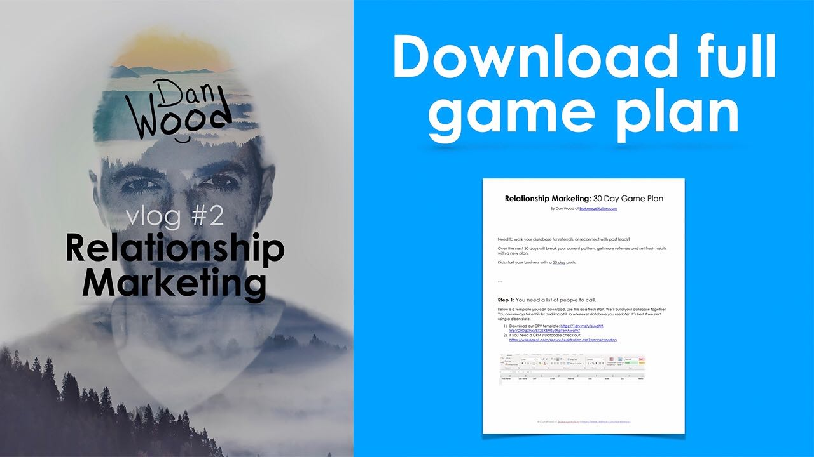

Title:
Relationship marketing ideas for a referral business | Vlog 2

YouTube Video Link:
https://youtu.be/ITlNNrW7OeY

Description:
If calling your database (and asking for referrals) makes you feel like a pest... watch this. In truth you'll always feel awkward when calling and the reason of the call is for business. Especially if you haven't talked to them in a long time.
I suggest you call with a softer touch just to break the ice and build a fresh relationship. You can always fit in the business side when and if the conversation is flowing that way.
This is vlog number 2 in my new series. A comment is worth a million bucks to me. Please make me feel rich by interacting with me below. I really do want to make this more like a community.

Transcription:
Hey, what's up? It's Danny Wood here. I wanted to do vlog number two, which was going to be on relationship marketing. And a lot of real estate agents, they feel awkward when they're calling their database and I can totally relate. I'll tell you why. One of my life's goals is to have joy with everything that I do, and if I don't have joy doing it, I don't want to do it. Especially when it comes to work. We're trading time for money. It's one of the most valuable things. Time. And we're just wasting it on things that we don't like doing. So if it's not bringing me joy, I don't want to do it. And the joy totally was sucked out of me. As soon as I got into the real estate business, I walked in the front door and they gave me a wadded up crusty bunch of pieces of paper glued together.
I think they call it a phone book and they wanted me to go through such a book and cold call these people. I'm like, "Hold on, cowboy. I'm out on the middle of a desert, but that doesn't mean that's what I want to do. Anything else you can suggest for me?" And they're like, "Yeah, we got a couple more brick walls for you. How about you bug your sphere of influence? I mean, call your sphere of influence?" I'm pretty sure it's what they said. Yeah. I had to call my sphere of influence, my friends and family, Hey Joey, it's Danny Wood here. I haven't talked to you in 20 years, but I got my real estate license now and I'm really eager for that commission. How are the kids?" It didn't sit well with me. I didn't want to do that. So I'm like, "Okay, what else you've got?"
And they're like, "Well how about you prospect complete strangers for sale by owners and inspireds" and I'm like, "Oh my gosh, this is not why I got into business. I don't feel good. I don't want to show up and do this sort of thing." And this is the truth. It's hard for you to be inspired when you feel like an ass and if you don't have a good reason for why you're calling people you feel like ... and it wasn't until I discovered I needed a why that was bigger than me. Before with all the other past sales training I was taking, it was all about business first and it didn't sit well with me. So what I started doing was calling people for bigger reasons, that was more about them than it was for me. I came up with a two plan system. Plan A was the reason for the phone call, A stands for awesome.
Anything that was fun, positive and share worthy. That's why I was calling them. Plan B was business and I would pepper that in the conversation when, if and where it felt fitting. I never force the business conversation, I just let it flow. Let me show you a couple of examples.
You should gather a couple of agents from your office and do a yearly clothing drive. It's something you can all add to your marketing calendar as a yearly event. You'll be able to reconnect with everybody in your database with a positive touch point. It's easy. You just call them up and say, "Hey, we're doing a clothing drive. I'll swing by and pick it up. Would you participate? Just put it in the bag." A lot of people will say, "Yeah". And now what's happening is you got a face to face conversation because you're going to swing by and see them.
You're updating your database with their mailing address and their home address, which is key for a real estate agent to have and it's something you can do even quarterly if you wanted, but at least yearly do it as a group. You'll get positive press release. You can have a blog, social media and a whole bunch of stuff out of it. Above and beyond, just you connecting with people on a positive level.
Now we've all gone through these calling programs and coaching programs where they have us burn through our database for the first time and it's a blitz and you're like taking selfies of you doing and that's great. However, if you ask most agents three months later, if they're still doing it, they aren't. Most aren't. And the reason for that is because the second, third and fourth phone call, you run out of ideas.
Now remember I said everything I do is all about joy and it's inside me. Well on a quarterly basis I would set something in the future that was fun and totally random and experiential like a Segway tour or a fishing trip or poker, wine, beer tasting, it doesn't matter. It was always experiential and fun and that gave me another reason to connect with people and it was always different.
One time it might be a self-defense class, another time it could be a CPR course or maybe it's a make and take where it's a seasonal thing and we all show up, make stuff and then take it home based on that holiday. Be creative but have something on your horizon at all time because that's what makes it easier to pick up the phone and enroll people. Now as a self-employed professional, you obviously know other self-employed professionals and a lot of people in your database are going to be self-employed as well.
So why don't you do a share intel where everybody shows up at a restaurant or something and they go around table and talk about who they are and what they sell, like their product and service and then they tell one example of how they generate business. That's going to create cross pollination between other people in the room. So not only are you going to be the key player, the person in the center that organized the whole thing, but everybody else is going to get value from it and maybe you can do it on a quarterly basis, maybe even monthly if it gets big.
Now the whole time I'm calling people about my plan A in the back of my mind I'm thinking of plan B. When it's fitting, I'm going to slide in the business conversation depending on who the people are and more importantly depending how the conversation is currently going. If it's uplifting and I feel like they have time to talk a little bit longer, I'm going to go into plan B.
So an example of plan B is the homeowners. If you know somebody who owns a home, which I hope you do, you can call through your database and let them know, "Hey, we got this nosy neighbor alert and it will keep you updated on all the homes that hit the market. Just in your neighborhood. You'll see the pictures, the price, the home renovations, that sort of thing. It's free and it's easy. What's the best email?"
And now you're updating your database with homeowners, getting their email and their address, so that you can let them know of what's happening directly in their neighborhood. It's free for you, it's free for them, it's relevant to them. If you are going to create a drip program, this is the first one that you should do and it's absolutely free. A lot of people that you know are in business and or self-employed and into investing maybe. And if so you could do a monthly tour looking at duplexes, triplexes, fix and flips, power sales, that sort of thing.
And then I would create a smaller list of just the people in my database who are investors and once a month we could meet up and do a little tour looking at property. The cool thing about investors is that they don't have any loyalty. And the reason why that's cool is because they don't have loyalty to the other agents either. So unless they're under contract, don't step on that, but most of the time it's just a relationship game and you got to be the one that has the relationship with them. This is an easy touch for sure. The other thing is anybody who is an investor in your database, they have two homes, the one they live in and the one they rent out. You're in this game for another five years or 10 years I hope, right? While that person is probably going to be buying or selling more property in the future, and this is a great touch.
A lot of the people we speak to are tenants and they're not a lost hope. If a person is a tenant, I would be like, "Hey, what's current rent go for where you're at?" And they would tell me, "Oh, it's around $1,400 or $1,600 or $2,200" and then I would respond, "Well that's crazy because I actually have a list of homes for sale that you can own and the monthly mortgage is the same as what you're paying in rent. Would you be interested in that?" Now I would only say that if it's true, I don't know what your market is, you might not be able to do that approach, but I can in my market, hopefully you can in yours. Now in the back of my mind the whole time I'm tuning into one of these business related reasons and the list goes on.
I just gave you three. There's more pillars. Some of you do pre construction, some of you do military specific property like cottages and waterfront and condos, anything. So, have all these business pillars in the back of your mind and then when you're having a conversation, just go with the flow and fit it in. It's more important to pick up the phone and be consistent with dialing than it is to like hammer them down to be a buyer right on the spot or a seller right on the spot.
Now, if your office wants to set up an accountability group, just let me know. I can do that in house. We can do it remotely. You can do it with the team or with the entire brokerage, so just reach out. If you don't want to pay me, you can just steal my ideas right here. Idea number one is that your agents should be calling three people a day, three a day, three a day, three a day.
It's slow and steady. I'd rather a person call their database for the next three months, then burn through their database in one month and then just never touched it again. See, you can't win a marathon if you don't know how to tie up your shoes. So three a day you don't have to readjust your time blocking. It's easy. Just call three people and then move on.
Idea number two is anybody that you're touching, you should be adding to your database with updated notes. So as much information as you can, their phone number, their email, their address, what you talked about. Now, of all the ideas, this next one is the most important. If anybody is important enough to be in your database, they're important enough to have a next call date. If you put somebody in your database and there isn't a next call date assigned, what's going to happen is three months goes by, six months, a year, two years, three years, and now you're like, Oh, my database sucks. It doesn't work."
Well, it wasn't that it's you weren't working it. So I like doing the manual approach where I'll manually add a next call date to a person, because if you try and automate this, your whole database gets out of whack. You'll know what your gut instinct. Should I call this person in a year? Should I call them in six months or next week? So you set the next call date and that's the most important tip that I have of the day. So everything we've covered so far, it gives you three or four touches that's face to face that you can build and grow your database with people who know, like and trust you and it's not annoying. It's something you can do consistently and I hope that you do. Anybody who is a coaching member of mine is going to get a copy of all the downloads and the templates.
I have agent versions. If you want access as your office, your whole office can have access and your team as well. But anybody who is a coaching member currently, they're going to get the full download of the game plan of what we just covered step-by-step. I'm even going to give you a tracking sheet so that you can make a game of it and have fun and bring joy back to your business.
A lot of people, they don't have a database. I'm like how many people you got? 60? What? 60 you're over the age of 18 you know more than 60 people. So what I want to do is I want to take you through a program that goes through your phone to find all the contacts, goes through your email to find the contacts through your database, through your social media and there's memory triggers where you have to fill in the blank, takes about an hour for you to do this.
But at the end of it you're going to have a fresh updated call list. Now you can work towards your relationship marketing. On top of all of this I'm going to give you my real estate scripts. If you want to get more business heavy where you are calling for sale by owners and that sort of thing. So, I want to throw it in as a bonus.
Hopefully you watch this whole thing. The sun is literally about to go down over this hill, and I don't know if you know anything about the desert or not, but when the sun goes down, it gets cold, and I literally tracked way the hell out here. I'm in the middle of nowhere. Often the distance is a tailgate party. It's a full moon tonight and they're going to howl at the moon. So hopefully I make it.

