Press Release & media on page 2.

BIO:
Danny Wood is a public speaker for major conferences and global brands. His focus is on marketing and technology. From generating leads, to lead follow up and after sale systems for repeat and referral business. He currently runs BrokerageNation a collection of 200 real estate offices and over 8,000+ agents who are enrolled in his online training programs. www.brokeragenation.com

Social:
Instagram: www.instagram.com/calldanwood
YouTube: www.youtube.com/user/DannyWoodVideos
Personal Facebook: www.facebook.com/DanWoodOshawa
Facebook Business Page: www.facebook.com/DanWoodCoaching

Headshots & logos:
https://www.brokeragenation.com/bio.html

Contact:
Dan Wood of Brokeragenation.com
coaching@danwood.ca
(905) 903-5442

Image:
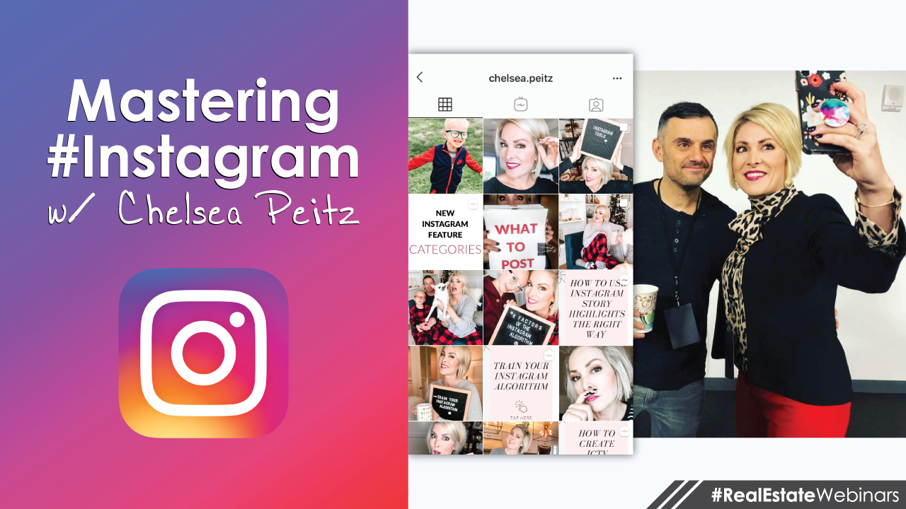

Title:
​Instagram For Real Estate Agents with Chelsea Peitz | Vlog 3 Danny Wood
YouTube Video Link:
https://youtu.be/qFjgxbzDcPQ

Description:
Chelsea Peitz and Danny Wood talked ideas during a webinar on how real estate agents can use Instagram. This is a summery of the 1 hour session they did. Highlights include:
- How to get Instagram swipe up link to website
- How the Instagram algorithm works
- Linktree and Shor.by
- Instagram story strategies
- Instagram Business Vs Personal account
- The Instagram highlight section
- Instagram analytics
- Adding a contact button and more!
Chelsea has a new book titled: "What to Post" and it covers how real estate agents can use Instagram to gain new business and reach a wider audience.
Add Danny Wood: https://www.instagram.com/calldanwood
Add Chelsea Peitz: https://www.instagram.com/chelsea.peitz
Buy her book: www.whattopostbook.com
More real estate training: www.patreon.com/DannyWood

Transcription:
Hey, what's up? My name is Danny Wood, this is blog number three. And today we're going to be covering Instagram tips and tricks. Now I was really fortunate to have Chelsea on my show. We did a full one hour webinar on Instagram marketing for real estate agents. This will apply to any industry, regardless of what you're in, but we focused on real estate just because. And one of the main things we want to have you do is work smarter, not harder, because a lot of people are spinning their wheels with Instagram. They don't feel like they're getting anything from it. So this is what we're going to cover it today.
Now if you want to go deeper, she does have a book, it's called What to Post. It's just released. WhatToPost.com is where you can get the book, and it's all about Instagram's strategies for the real estate industry. So I definitely encourage you head on over to that. But I want to uncover what we did for the webinars.
So we did a one hour webinar. I'm going to shrink it down as much as possible to just the highlights. The first thing she starts with is the user name and field name. And this name field, if you look at it, if you go to your account, you probably have a picture of you and then your name. It makes a lot of sense. But she says, "Instagram has two fields that are searchable, the name one and put the top and then the one underneath your profile picture." So the one under your profile picture, you should actually probably use for keywords, if you want free organic growth. So her example is better than my example. Her says, "Instagram for real estate."
So think of what are the things that you do. Toronto real estate? Maybe you want to put that in there because it's searchable. The rest of the bio is not searchable. So you really want to leverage this for all that you can. The main thing she's going to ask a person when she's doing an audit with them would be, "Are you on a business account or a personal account?" And a lot of people fear this because they don't want to be on a business account because we all know what happened with Facebook, with the business page. It's just like everything tanked, right? And you like the way it is.
Well, she says there's no negative impact on having a business account over the personal account. There's just a bunch of extra positives and bonuses that you get. So why would you want to miss on that? So there's no algorithmic difference whatsoever. So you should be on a business page. The only difference I found was if I posted something on my personal Instagram and I shared it, it would go to my personal Facebook and I liked that that was a good feature. But once I use the Instagram for business, then it wouldn't link the two. It wouldn't go into my personal Facebook. And that's the only drawback that I've found. But everything else is way worth it.
So first of all, you get a contact button. So you can add a contact button on your Instagram account now, and it's not new, but it might be new for you. Wouldn't you like to have people calling you? You can add a call, a text, or an email button right on at the top of the page. So I use this and I'm getting calls, right? And I'm not saying that you're going to use it and you're going to start getting calls, but if you're not using it, you're definitely not getting calls, right? So take a look at that. You can add a contact button, because you're using the business page.
During the live webinar. I was shocked to discover this, that it shows analytics of all of your content, and you can really slice it many different ways to look at it. But the main thing that I got was of my top three posts, all three of them were IGTV videos. Well, you know what that means to me? I need to make more IGTV videos. So it will show you what's working and what's not. And I'm not saying your answer is that you need to make Instagram TV videos. That's what my audience tunes into. But maybe your audience will tune into pictures of cats versus dogs, as an example. So you'll see the common threads and then you'll be able to maneuver strategically, working smarter and not harder.
In the bio, you should have a unique value proposition. So she's going to say, for example, her says, "I share real estate marketing tips that help you grow your biz & make more money doing what you love. DM me for free Instagram audit, helpful downloads, click here." So I love the two step process where she has two call to actions. One is for a direct message for a free audit and then the other one is to take action to go somewhere else. So I literally just copied her basically word for word, because if it works rock it.
So I said, "I help brokerages with recruiting and real estate agents with marketing message me for a free audit/consultation if you want to grow." And then I give them the link to take more action. So I really like that two step process where you add two unique value propositions into your bio. If you're not, then you're not getting anything right? So take a look, use what we're doing, modify it to be your own.
One of the things I discovered is that the Instagram stories, I thought they were all just deleted. They'll have a 24 hour shelf life and then they're gone. They're archived. So you can go back to all of your past stories, pull them together, and group them into different groups, like a highlight. At the top of this page here I have a banner and it has the different icon. So I put speaking, recruiting, marketing and blog. But maybe you want to highlight friends, family, food and fun, or whatever, right? Think of it as like a mindshare mission of all the things that you're up to in life and somebody goes to your Instagram account, what's the thing that you want them to know about
So that's what these groups are all about. And the fact that they're archived, you can go back in time and create a clean slate of a whole bunch of little groups of archived stories. It's pretty cool. You should be doing it. I don't know why you're not if you aren't. And you can head on over to Etsy and search Instagram story highlight icon, and there's hundreds of thousands of them already made. You can just buy them, $5, or $10, download a pack of them and then you've got concise, clean branding across the top of all of your highlights, like little buttons. And you can see mine here. There's a real estate example I put on the screen. There's tons of real estate examples that are already done for you. You don't even have to design them.
Now for our Instagram stories, we're using this approach. It's a strategy. We're looking at the screen size and then we're dividing it into three sections. The very top section is a banner for your branding, or a call to action, or whatever. And then we use negative space. That way we could add things like buttons and texts and stickers. And then underneath that is going to be the photo of the actual post. So when we post something, we actually break it up into three sections and we make sure to include lots of room for negative space. That way we can add things like hashtags and user names, or we could add things like interactive buttons. Otherwise, you're putting your content on top of other contents. So pre-build your story with the thought of having a negative space in mind.
Now, of all the tips and tricks that you're going to learn from anybody on any social media platform, the answer is always going to come down to engagement. So if for example, you have 500 friends on Instagram, and all 500 of them post something today, are you going to see all 500 posts? No, you're not. And so how does Instagram determine whose posts they're going to show you? Here's an example of how I did that strategy. I posted this on Facebook and I said, "Hey, we're doing a webinar. We're going to record it. You can join live. Who's interested?" That's basically what I said. And 180 people commented saying, "I do, I want it, this is my email", whatever. So I used it as an opportunity to build and grow my database and my sphere of influence.
Now had I just posted on Facebook saying, "Hey, I'm doing a webinar. This is the date and time. This is the link to register." Do you think I'd get 180 people? No, I'd probably get like five, or 10 or something. But because I got really interactive with it and I would comment and tag them back and then thank them and private message them, it's all part of the algorithm. So now when I do another event like this, I'm going to be higher on their awareness radar. It's awesome.
So the four main ways that you can increase your engagement would be direct messages, that's probably the biggest one. If you can get a real conversation with a real person and it goes back and forth multiple times, that's huge. So now when you post in the future, there's a good chance that they will see your posts. Comments, likes, story replies. Those are all easy little touches that don't cost you anything. It's just like, here's the thing, it's called social media for a reason. You got to be social with it. If you're not going to be social with it and you don't want to do it, that's fine, just don't waste your time not doing it. I'd rather you not even try, instead of you saying, "Yeah, I got Instagram. It doesn't work for me." It's cause you're not working it. You have to actually be interactive with people and not be shy.
Now of all the questions I was asked, this is the biggest burning one that people have, and that is how do you get that swipe up feature in your story when a person can swipe up and it will link them to your website. Instagram has a rule that you need a 10,000 followers before that will unlock and even some people that have 10,000 followers, that's not even unlocked for them yet. I'm going to share with you the answer, but I'm not going to give it to you. What I want you to do is I want you to go to Chelsea's Instagram account. I'm going to point to her name. Underneath her name. If you scroll down when you're on her profile is a IGTV button, Instagram Television. Click on that tab and then scroll down even further. And you're going to see this little video called Insta Story Swipe Up Hack Free, Under 10,000 Followers. So that video is going to break down how you can get that for free when you're under 10,000 followers.
So when you're there tell her I sent you, or tag me. I just want to know, did anybody actually go and watch the video? Because this is probably one of the biggest questions people have and I want to share it with you, but I don't want to give it to you. This is more like an Easter egg hunt so hopefully you appreciate it if you want the answer.
Now remember in the link description in the bio, you only have room for one link. Well we use tools, I use Shorby. This allows you to consolidate your call to actions, essentially. Because if you send people to your website, it's like a choose your own adventure. Who knows where they go. But with this, I can be way more tighter with my call to actions and the products and services that I'm offering. So these tools are really cool. I really encourage you to take a look at it, only if you have a lot of engagement, traffic and followers. If you don't, then save your money. You probably don't need these tools whatsoever.
However, if you do like free advice and you want to hang out a little more, this is my Instagram account. This is the Chelsea's Instagram account. You can take a picture of the screen by scanning the code, or just look us up by typing our usernames down below. That's it. That was video number three. This is the third blog I've done. Number four is coming up. I do a bi-weekly vlog and I encourage you to comment below. This is the only thing I care about. You can like and you can share and do all that other stuff. Awesome. But if you comment nothing makes me glow better than that, so thanks a lot.

