Press Release & media on page 2.

BIO:
Danny Wood is a public speaker for major conferences and global brands. His focus is on marketing and technology. From generating leads, to lead follow up and after sale systems for repeat and referral business. He currently runs BrokerageNation a collection of 200 real estate offices and over 8,000+ agents who are enrolled in his online training programs. www.brokeragenation.com

Social:
Instagram: www.instagram.com/calldanwood
YouTube: www.youtube.com/user/DannyWoodVideos
Personal Facebook: www.facebook.com/DanWoodOshawa
Facebook Business Page: www.facebook.com/DanWoodCoaching

Headshots & logos:
https://www.brokeragenation.com/bio.html

Contact:
Dan Wood of Brokeragenation.com
coaching@danwood.ca
(905) 903-5442

Title:
​YouTube ideas for real estate agents | Vlog 4 Danny Wood
YouTube Video Link: https://youtu.be/P27ghhL0LfM

Images:
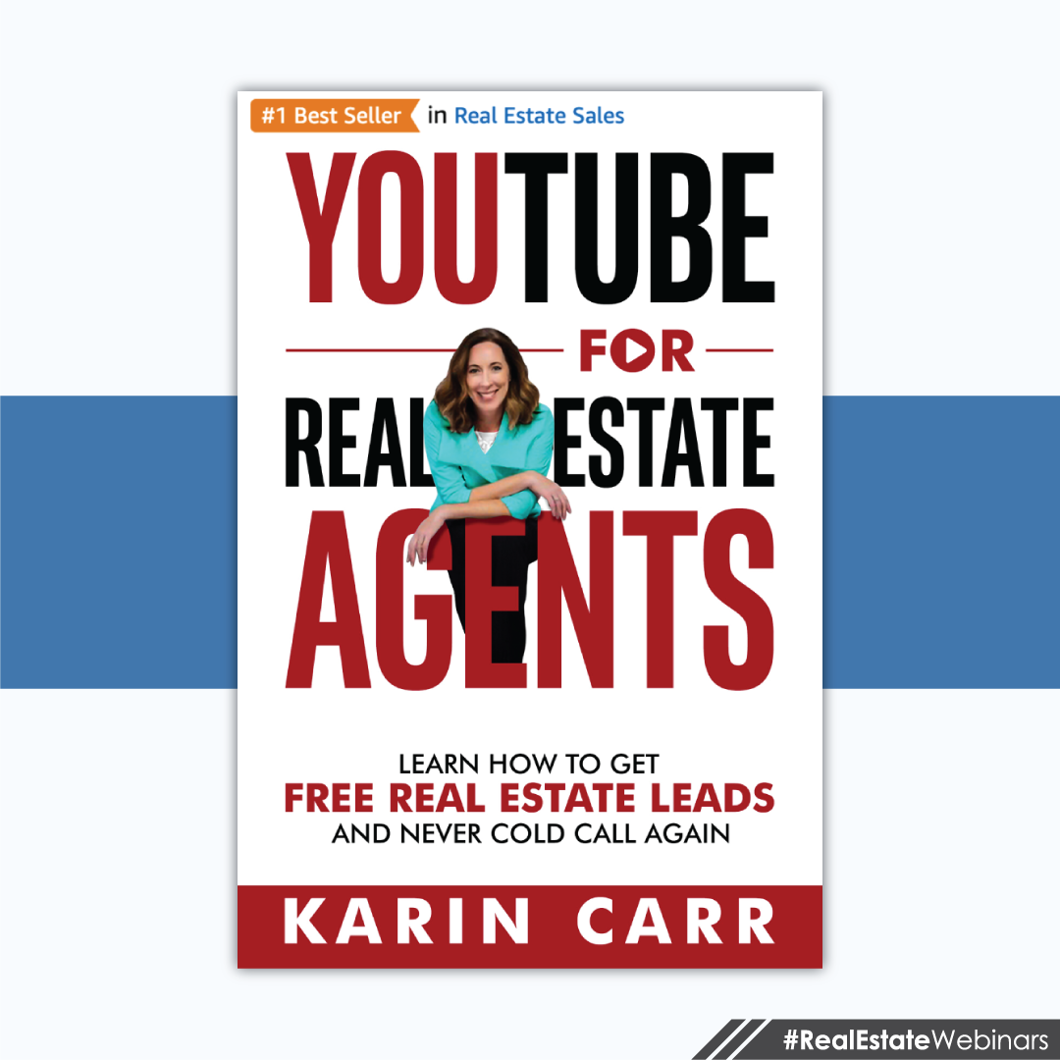
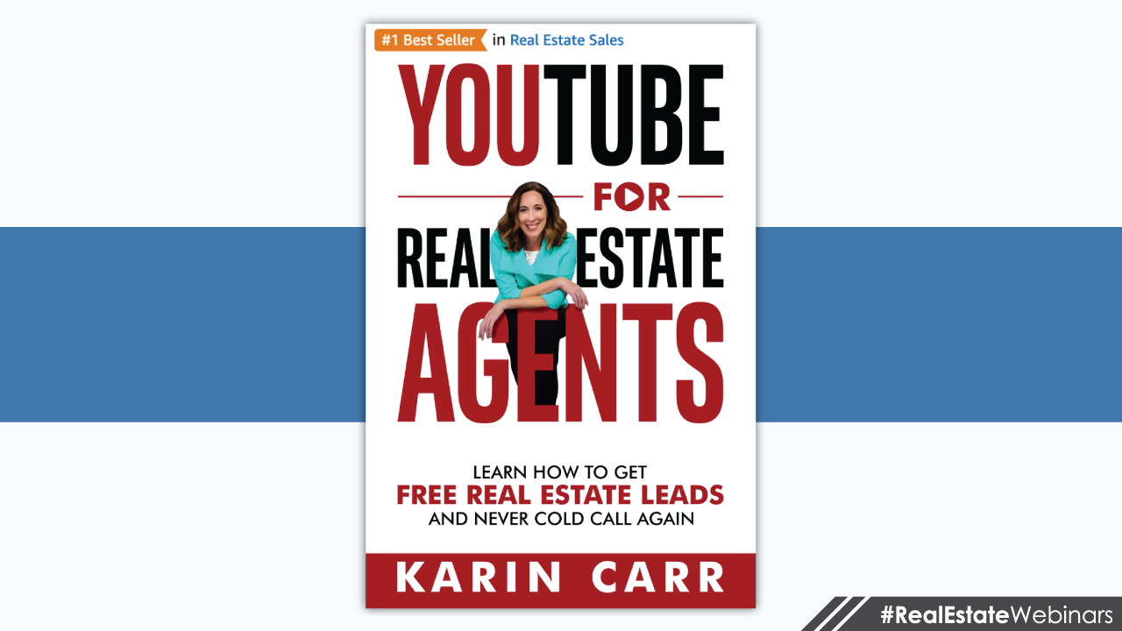

Description:
I invited special guest Karin Carr to discuss how real estate agents are using YouTube. We did a full webinar (ask me for a copy), but I'll summarize it for you in this video. Ideas we covered:
1) Her book: https://amzn.to/2u4OZGH
2) YouTube is a search engine and so is Google. You should post free videos to get found.
3) The top three videos agents should make.
4) How Google suggests keywords you can use as ideas for your next videos.
5) How www.answerthepublic.com can show you what the public is searching based on the topic of real estate and home buying.
6) Keyword research tool: www.keywordseverywhere.com
7) The 5 second rule. Skip the animated logo intros and get right to the point.
8) www.fiverr.com & www.upwork.com are great places to outsource video editing.
9) PromptSmart Pro is a teleprompter app for your phone that helps with longer scripts and self filming.
10) Keynote & PowerPoint are both apps you can use to help tell your story.
11) WeVideo & LumaFusion are the editing apps we use.
12) Get royalty free music from www.epidemicsound.com & https://freemusicarchive.org/music/charts/all Ask me for a copy of the the full webinar. 905-903-5442 #RealEstateMarketing #RealEstateForAgents
More real estate training: www.patreon.com/DannyWood
YouTube channel for Danny Wood: https://www.youtube.com/user/DannyWoodVideos
YouTube channel for Karin Carr: https://www.youtube.com/user/SixFootRealtor

Transcription:
Hey, what's up? This is Danny Wood. This is blog number four, and on this one we're covering YouTube, specifically how real estate agents can use YouTube to get buyers and sellers. Now, we did a full webinar with special guest, Karen Carr. She actually wrote a book on how real estate agents are using YouTube. I highly suggest you check that out. And a lot of people don't know this, but you don't actually need an eReader, like a Kindle or whatever these things are called, you can just use your phone. So just buy the book on Amazon using your phone and you can use Amazon's app directly on your phone to read the book, or get the paper version, which is probably better. So check it out, YouTube For Real Estate Agents. We're going to dive deep on the webinars. So, we did a webinar, it was a full one hour webinar, and we got all these great ideas, and I'm going to summarize it for you.

So idea number one that you should be aware of is that YouTube is a search engine, but so is Google. And so when you go to Google and search things, like here I search moving to Savannah, guess whose video pops up in Google on the homepage for free up at the top. Karen's video. And your video should, when we do the same search in your city. So these are the top videos that Karen's using in her area. So, Living in Savannah, you should do one living in your city, Moving to Savannah, Is it cheaper to buy or build a house? Now this one's generic, and I would probably stay away from doing generic videos and being more niche to your community and the city and town that you serve, because you're just going to be more relevant and local.

How long does it take to close on a house? So that's another generic one. Cities Near Savannah. So of her top five videos, three of them are specific to her local area. So there, I just shortened your learning curve. Those are the first three videos that you should consider making, because they're working for her, and I doubt anybody's doing videos in your area, so they can be working for you as well. So here's an example of me going to Google and doing a search. This is another little hack that you should be aware of. When you type anything into the Google search bar, it will pop up with a bunch of suggestions. Those are based on the top search terms that people are actually doing. So Google is trying to make it easier for people to click and just get to what they want. Well, as an advertiser, this is market research. This is showing me when I type in Toronto real estate, these are the top things that people are searching. So maybe these are the types of videos that I should be covering and talking about.

Now another tool that we discovered is Answer The Public. So if you go to answerthepublic.com, and type in buying a home. So as a keyword or a topic, I want to know what are people asking about buying a home. Answer The Public is going to do all this stuff in the background and then pop off a list. So here it gave me 38 questions that people are asking online about buying a home. I'll zoom in. It's going to be kind of blurry because I have to stretch it out a little. The first one here says, "How is buying a home a good investment?" That's a great video that you could make, and I would be specific. How is buying a Toronto home a great investment? So get a little more niche with it.

How does buying a foreclosed home work? How does buying a home help with taxes? How does buying a home affect your credit? So all of these questions, there's 38 of them, that's a benchmark and a game plan for you to work towards making video content. You can just go to Answer The Public, and it's going to give you the content that you should be making, or at least consider making. Now another tool Karen discussed, I haven't used this one yet, but I certainly am going to now, it's called Keywords Everywhere. And what's really cool about this program, I'll zoom down, it's not monthly or subscription. You just buy credits. So for $10, you can buy 100,000 credits, and one credit equals one keyword. So you can do research on all the different keywords in your area, and it's going to tell you what's working, what's not, and suggested keywords. It's a really cool tool, and the fact that it's just $10 and most of you will never need more than that, it's a good little resource. I'm glad she told us about that one.

She also told us about the five second rule, and that's your opening of the video. You got to get right to the point. You can't have those canned animated logo sequences that you buy off of Fiverr, for example. It's just not that good of an idea, because people don't care about you and your brand and your logo. They care what's the video about, and how's it going to help me? So you need to get into the five W's, the who, what, where, when, why, and get right to the point. Some people can get away with having slow motion animated sequences of you opening the door and looking all cool and the wind's blowing in your hair and stuff. If you can rock it, great, but I'd say most people don't care about you that much, and they care more about the content that they're about to watch, so just get right to the point if you can. Now speaking of Fiverr, one of the things that you can do on Fiverr that's a great idea, is outsourcing your video editing.

So you can go to Fiverr and find a whole bunch of video editors that can work for like $5, $10, $30, $60, whatever you want to pay depending on the quality, and Fiverr is a really good resource for that. Now, I personally don't use Fiverr as much as I use Upwork. I love Upwork. I'll tell you a story. Upwork is where I find virtual assistants. One of the franchises paid me to go do a talk and hang out in Mexico, which was awesome. And I took a GoPro, and I got to hang out with all the agents, and we went off site and did a bunch of excursions, like kayaking, and zip lines, and Coco Bongo's, and a couple of other things. And I brought a GoPro. Captured all this amazing footage, but then, when I got home, I didn't have time or the knowledge or want to actually do anything with that footage.

So I went to Upwork and I created a contest. I hired five virtual assistants who all do video editing. I gave them all the same folder and said, "Here, you just make the best video that you can. Tell me a story with the footage here." And one of the guys blew me out of the water. It was like he made a music video based on my fun excursion. So now going forward, I know what virtual assistant is going to get all of my video editing. So, over the long haul, it's going to save you a lot of time and hassle. It might cost you more money up front, but it's the best way to hire and find people.

Just hire three or four of them, and then pick the winner, and going forward, you know this is the person I want to use for this specific task. I have one girl who only does animated voiceovers. She has a way sexier voice than I do, so I get her to do a lot of my voice work. And I have another person that only does banner ads for Google. I found all these virtual assistants that have one niche that they focus on, and I just pay them per project. That's cool way of doing it.

Now, one of the things that people love hearing us talk about are the apps that we use. So we're going to slide right into that. The first one is PromptSmart Pro, and this is a teleprompter that works on your phone, and it puts the text right underneath the camera. So it looks like I'm looking right into the camera, but I'm actually reading text and this text is scrolling as I talk. So if I stop talking, the text stops scrolling. Really, really cool app. It's going to help a lot of you out. I know it helped me out. Now, I don't use that anymore. What I like to do is this, where I do Keynote. So I have my video split into two, where half of it is me, and then the bottom half is my keynote. The keynote is just to keep me on track. This is my script. This is my teleprompter. And the other benefit to it is that I'm recording my screen at the same time, and now I have overlay footage that references what I'm talking about. So it's a win-win.

Now, keynote is a free app, but it's only free on iPhone and iPad. And some of you are like, "Ugh, I hate iPhone. I only use Android." All right, so then you're going to want to check out PowerPoint. PowerPoint has an app that works on your phone and on your tablet, and you can make your presentations and use that as your script. So there you go. One of the tools that Karen uses for editing video is WeVideo. She does all her video editing from a desktop computer. I don't know if she's used the app. I searched the app just for you to see that there was one. I don't know if it's any good or not, but everybody raves about the desktop version of it. They have an iPad version and an Android version, so check it out. It might work for you. I don't use it. The one I use is LumaFusion. Hands down, nothing beats editing video on your iPad or on your iPhone when you use LumaFusion. But it's only iOS, and not Android, so that sucks for some of you.

Now when it comes to good video, one of the other things you need is great audio. Free Music Archive is a free place, you don't need to give credit card. You can download royalty free music that can be playing in the background while you're talking, and it kind of covers up the fact that you're using a crappy microphone, or there's ambient background noise. You can use free music from Free Music Archive, and it's pretty cool. It's really nice music, especially for the price. It's free. I don't use it anymore, because I use Epidemic. I create so much video that having a monthly subscription for really premium audio is worth it to me, and it might be worth it to you. So checkout Epidemic. This is where I get all of my music and sound effects. So Epidemic is a really, really cool service, but it's monthly and a lot of agents might not need that.

Now one of the hottest things that we talk about is the gear to use, but I have to pause and continue with this video later on. So, in a future video, if you want access to the live webinar that we did, we talk about the gear, we talk about the lights, the mics, and the stands, and all the other accessories that we use. So if that's something that you want to tune into, head on over to patreon.com/dannywood. It's $20 a month. You can cancel after one month if it doesn't fit with you. And we do two live coaching calls for real estate agents every month, specifically on marketing and technology. So our next webinar is going to be on YouTube advertising, on how you can get ahead of all the other realtors in your city. So if that sounds like something you'd want to tune into, join me patreon.com. That's it for a vlog number four. Join me on vlog number five in about two weeks. Okay, thanks.

